==========================================================================================

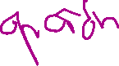

4 Caso primer repetido = 3



3 13 7 9 6 12 2 8



==========================================================================================

=============================== ===============================



J3: |Q3Q2/Q1Q0| 00 | 01 | 11 | 10 | K3: |Q3Q2/Q1Q0| 00 | 01 | 11 | 10 |



| 00 | x | x | x | x | | 00 | x | x | 1 | 1 |



| 01 | x | x | x | x | | 01 | x | x | 1 | 1 |

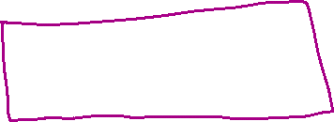

| 11 | 1 | 1 | x | x | | 11 | x | x | x | x |

| 10 | 1 | 1 | x | x | | 10 | x | x | x | x |



=============================== ===============================



=============================== ===============================

J2: |Q3Q2/Q1Q0| 00 | 01 | 11 | 10 | K2: |Q3Q2/Q1Q0| 00 | 01 | 11 | 10 |

| 00 | x | x | x | 0 | | 00 | x | x | 1 | x |



| 01 | x | x | x | 1 | | 01 | x | x | 0 | x |



| 11 | 1 | x | x | x | | 11 | x | 1 | x | x |



| 10 | 0 | x | x | x | | 10 | x | 0 | x | x |

=============================== ===============================



=============================== ===============================

J1: |Q3Q2/Q1Q0| 00 | 01 | 11 | 10 | K1: |Q3Q2/Q1Q0| 00 | 01 | 11 | 10 |

| 00 | x | x | 1 | 1 | | 00 | x | x | x | x |

| 01 | x | x | 1 | 1 | | 01 | x | x | x | x |

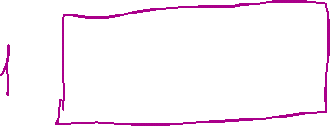

| 11 | x | x | x | x | | 11 | 1 | 1 | x | x |

| 10 | x | x | x | x | | 10 | 1 | 1 | x | x |

=============================== ===============================

=============================== ===============================

J0: |Q3Q2/Q1Q0| 00 | 01 | 11 | 10 | K0: |Q3Q2/Q1Q0| 00 | 01 | 11 | 10 |



| 00 | x | x | 0 | 1 | | 00 | x | x | x | x |



| 01 | x | x | x | x | | 01 | x | x | 0 | 1 |



| 11 | x | x | x | x | | 11 | 0 | 0 | x | x |

| 10 | 0 | 0 | 0 | x | | 10 | x | x | x | x |

=============================== ===============================



==========================================================================================

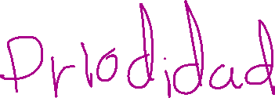

4 Caso segundo repetido = 3

7 13 3 9 6 12 2 8

==========================================================================================



=============================== ===============================

J3: |Q3Q2/Q1Q0| 00 | 01 | 11 | 10 | K3: |Q3Q2/Q1Q0| 00 | 01 | 11 | 10 |

| 00 | x | x | x | x | | 00 | x | x | 1 | 1 |

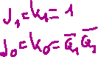

| 01 | x | x | x | x | | 01 | x | x | 1 | 1 |

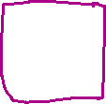

| 11 | 1 | 1 | x | x | | 11 | x | x | x | x |



| 10 | 1 | 1 | x | x | | 10 | x | x | x | x |



=============================== ===============================



=============================== ===============================

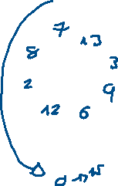

J2: |Q3Q2/Q1Q0| 00 | 01 | 11 | 10 | K2: |Q3Q2/Q1Q0| 00 | 01 | 11 | 10 |



| 00 | x | x | x | 1 | | 00 | x | x | 1 | x |



| 01 | x | x | x | 1 | | 01 | x | x | 1 | x |



| 11 | 0 | x | x | x | | 11 | x | 0 | x | x |

| 10 | 0 | x | x | x | | 10 | x | 0 | x | x |

=============================== ===============================



=============================== ===============================

J1: |Q3Q2/Q1Q0| 00 | 01 | 11 | 10 | K1: |Q3Q2/Q1Q0| 00 | 01 | 11 | 10 |

| 00 | x | x | 1 | 1 | | 00 | x | x | x | x |

| 01 | x | x | 1 | 1 | | 01 | x | x | x | x |

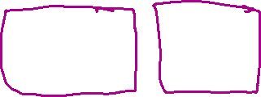

| 11 | x | x | x | x | | 11 | 1 | 1 | x | x |

| 10 | x | x | x | x | | 10 | 1 | 1 | x | x |

=============================== ===============================

=============================== ===============================

J0: |Q3Q2/Q1Q0| 00 | 01 | 11 | 10 | K0: |Q3Q2/Q1Q0| 00 | 01 | 11 | 10 |

| 00 | x | x | 0 | 1 | | 00 | x | x | x | x |



| 01 | x | x | x | x | | 01 | x | x | 0 | 1 |

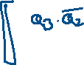

| 11 | x | x | x | x | | 11 | 0 | 0 | x | x |

| 10 | 0 | 0 | x | x | | 10 | x | x | x | x |

=============================== ===============================

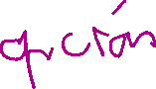

==========================================================================================

3 Caso segundo repetido = 5



7 13 5 9 6 12 2 8

==========================================================================================



=============================== ===============================



J3: |Q3Q2/Q1Q0| 00 | 01 | 11 | 10 | K3: |Q3Q2/Q1Q0| 00 | 01 | 11 | 10 |



| 00 | x | x | x | x | | 00 | x | x | 1 | 1 |



| 01 | x | 1 | x | x | | 01 | x | x | 1 | 1 |

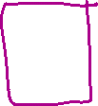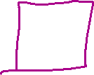

| 11 | x | 1 | x | x | | 11 | x | x | x | x |



| 10 | 1 | 1 | x | x | | 10 | x | x | x | x |

=============================== ===============================



=============================== ===============================

J2: |Q3Q2/Q1Q0| 00 | 01 | 11 | 10 | K2: |Q3Q2/Q1Q0| 00 | 01 | 11 | 10 |

| 00 | x | x | x | 1 | | 00 | x | x | 1 | x |



| 01 | x | x | x | 1 | | 01 | x | 1 | 0 | x |

| 11 | x | x | x | x | | 11 | x | 0 | x | x |

| 10 | 0 | x | x | x | | 10 | x | 0 | x | x |

=============================== ===============================



=============================== ===============================

J1: |Q3Q2/Q1Q0| 00 | 01 | 11 | 10 | K1: |Q3Q2/Q1Q0| 00 | 01 | 11 | 10 |



| 00 | x | x | 1 | 1 | | 00 | x | x | x | x |



| 01 | x | 0 | 0 | 1 | | 01 | x | x | x | x |

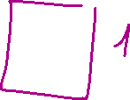

| 11 | x | x | x | x | | 11 | x | 1 | x | x |

| 10 | x | x | x | x | | 10 | 1 | 1 | x | x |



=============================== ===============================



=============================== ===============================

J0: |Q3Q2/Q1Q0| 00 | 01 | 11 | 10 | K0: |Q3Q2/Q1Q0| 00 | 01 | 11 | 10 |

| 00 | x | x | 0 | 1 | | 00 | x | x | x | x |

| 01 | x | x | x | x | | 01 | x | 0 | 0 | 1 |



| 11 | x | x | x | x | | 11 | x | 0 | x | x |

| 10 | 0 | 0 | x | x | | 10 | x | x | x | x |

=============================== ===============================



==========================================================================================

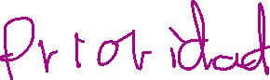

3 Caso segundo repetido = 15

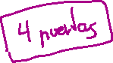

7 13 15 9 6 12 2 8

==========================================================================================

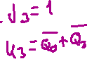

=============================== ===============================

J3: |Q3Q2/Q1Q0| 00 | 01 | 11 | 10 | K3: |Q3Q2/Q1Q0| 00 | 01 | 11 | 10 |



| 00 | x | x | x | x | | 00 | x | x | 1 | 1 |



| 01 | x | x | x | x | | 01 | x | x | 0 | 1 |

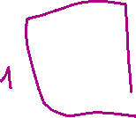

| 11 | x | 1 | x | x | | 11 | x | x | 0 | x |



| 10 | 1 | 1 | x | x | | 10 | x | x | x | x |



=============================== ===============================



=============================== ===============================



J2: |Q3Q2/Q1Q0| 00 | 01 | 11 | 10 | K2: |Q3Q2/Q1Q0| 00 | 01 | 11 | 10 |



| 00 | x | x | x | 1 | | 00 | x | x | 1 | x |

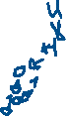

| 01 | x | x | x | 1 | | 01 | x | x | 0 | x |



| 11 | x | x | x | x | | 11 | x | 0 | 1 | x |



| 10 | 0 | x | x | x | | 10 | x | 0 | x | x |



=============================== ===============================



=============================== ===============================

J1: |Q3Q2/Q1Q0| 00 | 01 | 11 | 10 | K1: |Q3Q2/Q1Q0| 00 | 01 | 11 | 10 |

| 00 | x | x | 1 | 1 | | 00 | x | x | x | x |



| 01 | x | x | 1 | 1 | | 01 | x | x | x | x |

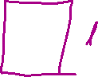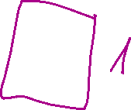

| 11 | x | x | x | x | | 11 | x | 1 | 1 | x |

| 10 | x | x | x | x | | 10 | 1 | 1 | x | x |

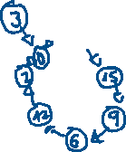

=============================== ===============================

=============================== ===============================

J0: |Q3Q2/Q1Q0| 00 | 01 | 11 | 10 | K0: |Q3Q2/Q1Q0| 00 | 01 | 11 | 10 |

| 00 | x | x | 0 | 1 | | 00 | x | x | x | x |

| 01 | x | x | x | x | | 01 | x | x | 0 | 1 |

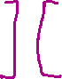

| 11 | x | x | x | x | | 11 | x | 0 | 0 | x |

| 10 | 0 | 0 | x | x | | 10 | x | x | x | x |

=============================== ===============================

